Hill Stations:

Khanspur

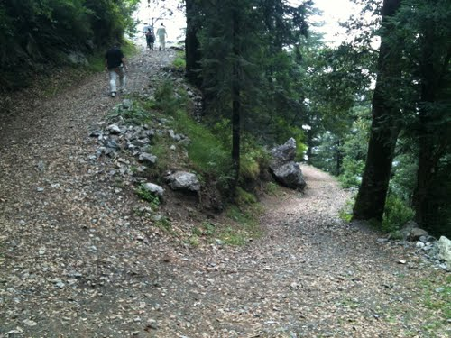

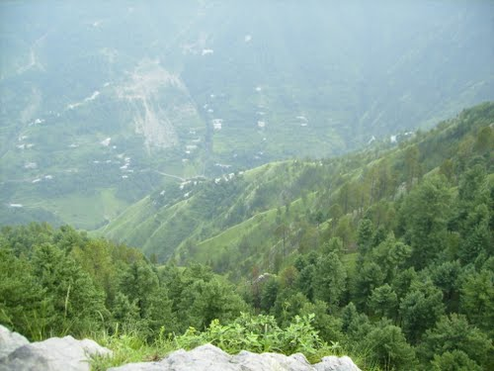

**Khanaspur** is one of the tourist mountain resort towns of the Galyat area of Hazara region of the Khyber Pakhtunkhwa. Khanaspur is a settlement in the Ayubia area and is located in Abbottabad District in Khyber Pakhtunkhwa province of Pakistan. It also has the Punjab University Hostel. It also had the Bhutto House. During British rule it was occupied by a detachment of British infantry. It is situated at an altitude of about 2,250 metres (7,382 ft).

The average temperature during the months of June–September ranges from 21 °C to 26 °C with cool nights. During winter, snowfall is common with tropical alpine environment.